МИНИСТЕРСТВО НАУКИ И ВЫСШЕГО ОБРАЗОВАНИЯ РОССИЙСКОЙ ФЕДЕРАЦИИ

ФЕДЕРАЛЬНОЕ ГОСУДАРСТВЕННОЕ БЮДЖЕТНОЕ ОБРАЗОВАТЕЛЬНОЕ

УЧРЕЖДЕНИЕ ВЫСШЕГО ОБРАЗОВАНИЯ

«МОСКОВСКИЙ АВИАЦИОННЫЙ ИНСТИТУТ

(национальный исследовательский университет)»

ОТЧЕТ ПО ЛАБОРАТОРНЫМ РАБОТАМ №5 и №6

по курсу «Виртуальные динамические модели и цифровые двойники»

Выполнил:

Студент группы М80-201М-21

Фейзуллин Кирилл Маратович

Вариант - 13

**Лабораторная работа №5**

**Задание**

По заданной схеме смоделировать кинематику системы плоских тел.

**Вариант 13**

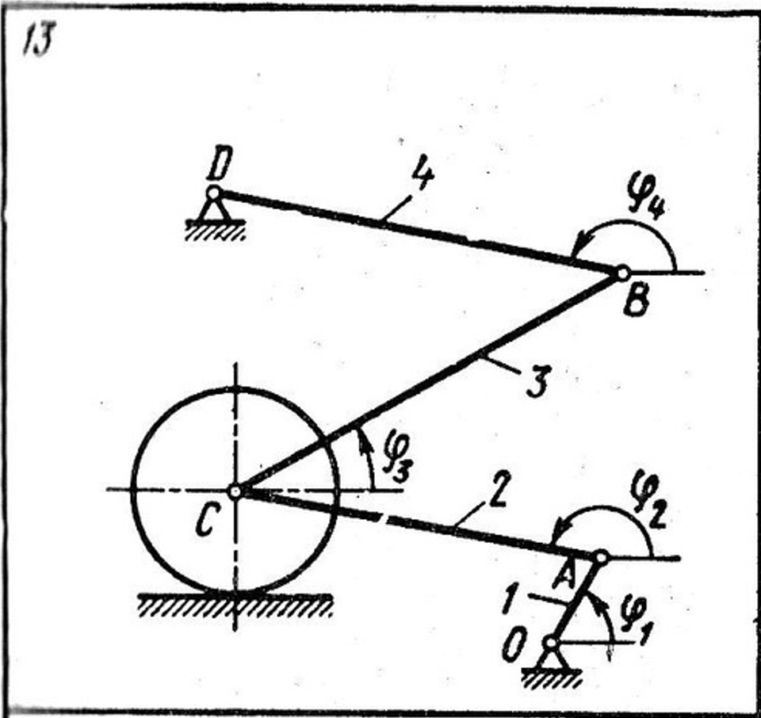

Для упрощения программирования, укажем направления палок относительно шарнира для их крепления:

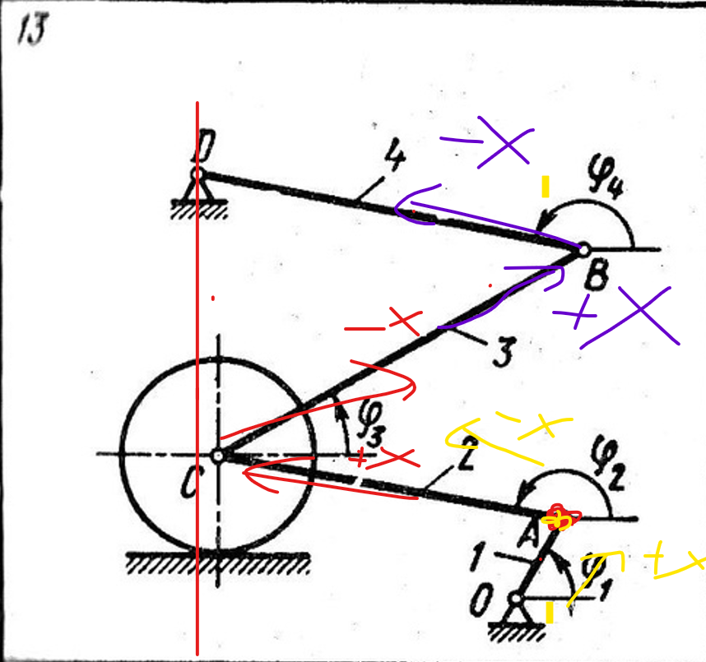

**Результат работы**

Код программы:

package Lab_5_Kinematica

model Body2D

parameter Modelica.Mechanics.MultiBody.Frames.Orientation orientation = Modelica.Mechanics.MultiBody.Frames.axesRotations({1, 2, 3}, {0, 0, 0}, {0, 0, 0});

parameter Real Color[3] = {0, 0, 255};

Modelica.Units.SI.Length X;

Modelica.Units.SI.Length Y;

Modelica.Units.SI.Angle Phi;

KinematicOutput Body_Out;

equation

Body_Out.X = X;

Body_Out.Y = Y;

Body_Out.Phi = Phi;

end Body2D;

connector KinematicInput

input Modelica.Units.SI.Length X;

input Modelica.Units.SI.Length Y;

input Modelica.Units.SI.Angle Phi;

end KinematicInput;

connector KinematicOutput

output Modelica.Units.SI.Length X;

output Modelica.Units.SI.Length Y;

output Modelica.Units.SI.Angle Phi;

end KinematicOutput;

model Rod2D

extends Fejzullin_Lab_5_6.Lab_5_Kinematica.Body2D;

parameter Modelica.Units.SI.Length L = 1;

Modelica.Mechanics.MultiBody.Visualizers.Advanced.Shape RodShape(shapeType = "box", length = L, width = 0.1, height = 0.1, lengthDirection = {cos(Phi), sin(Phi), 0}, widthDirection = {0, 0, 1}, color = Color, specularCoefficient = 0.5, r = {X - L / 2 * cos(Phi), Y - L / 2 * sin(Phi), 0}, R = orientation);

equation

annotation(

experiment(StartTime = 0, StopTime = 1, Tolerance = 1e-6, Interval = 0.002));

end Rod2D;

model FreeRod

parameter Modelica.Units.SI.Length L = 2;

Rod2D Palka(L = L, Color = {0, 255, 80});

equation

Palka.X = L / 2 * sin(time);

Palka.Y = L / 2 * cos(time);

Palka.Phi = time;

annotation(

experiment(StartTime = 0, StopTime = 10, Tolerance = 1e-06, Interval = 0.0002));

end FreeRod;

model Wheel2D

extends Fejzullin_Lab_5_6.Lab_5_Kinematica.Body2D;

parameter Modelica.Units.SI.Length R = 1;

Modelica.Mechanics.MultiBody.Visualizers.Advanced.Shape WheelShape(shapeType = "cylinder", length = 0.1, width = 2 * R, height = 2 * R, widthDirection = {cos(Phi), sin(Phi), 0}, lengthDirection = {0, 0, 1}, color = Color, specularCoefficient = 0.5, r = {X, Y, 0}, R = orientation, r_shape = {0, 0, 0});

Modelica.Mechanics.MultiBody.Visualizers.Advanced.Shape BoxShape(shapeType = "box", length = 0.2, width = R, height = R, widthDirection = {cos(Phi), sin(Phi), 0}, lengthDirection = {0, 0, 1}, color = 0.7 * Color, specularCoefficient = 0.5, r = {X, Y, 0}, R = orientation, r_shape = {0, 0, 0});

equation

annotation(

experiment(StartTime = 0, StopTime = 1, Tolerance = 1e-06, Interval = 0.002));

end Wheel2D;

model FreeWheel

parameter Modelica.Units.SI.Length R = 2;

Wheel2D Wheel(R = R, Color = {0, 255, 0});

equation

Wheel.X = R / 2 * sin(time);

Wheel.Y = R / 2 * cos(time);

Wheel.Phi = time;

annotation(

experiment(StartTime = 0, StopTime = 10, Tolerance = 1e-06, Interval = 0.0002));

end FreeWheel;

model Support2D

parameter Modelica.Units.SI.Length Xp = 0;

parameter Modelica.Units.SI.Length Yp = 0;

parameter Modelica.Units.SI.Length Xt = 0;

parameter Modelica.Units.SI.Length Yt = 0;

parameter Real Color[3] = {0, 0, 0};

parameter Modelica.Mechanics.MultiBody.Frames.Orientation orientation = Modelica.Mechanics.MultiBody.Frames.axesRotations({1, 2, 3}, {0, 0, 0}, {0, 0, 0});

Modelica.Mechanics.MultiBody.Visualizers.Advanced.Shape SupportShape(shapeType = "cylinder", length = 0.5, width = 0.2, height = 0.2, widthDirection = {1, 0, 0}, lengthDirection = {0, 0, 1}, color = Color, specularCoefficient = 0.5, r = {Xp, Yp, -0.2}, R = orientation, r_shape = {0, 0, 0});

KinematicInput Body_In;

equation

Xp = Body_In.X + Xt * cos(Body_In.Phi) - Yt * sin(Body_In.Phi);

Yp = Body_In.Y + Xt * sin(Body_In.Phi) + Yt * sin(Body_In.Phi);

annotation(

experiment(StartTime = 0, StopTime = 1, Tolerance = 1e-6, Interval = 0.002));

end Support2D;

model Joint2D

Modelica.Units.SI.Length Xsh;

Modelica.Units.SI.Length Ysh;

parameter Modelica.Units.SI.Length Xt1 = 0;

parameter Modelica.Units.SI.Length Yt1 = 0;

parameter Modelica.Units.SI.Length Xt2 = 0;

parameter Modelica.Units.SI.Length Yt2 = 0;

parameter Real Color[3] = {0, 0, 200};

parameter Modelica.Mechanics.MultiBody.Frames.Orientation orientation = Modelica.Mechanics.MultiBody.Frames.axesRotations({1, 2, 3}, {0, 0, 0}, {0, 0, 0});

Modelica.Mechanics.MultiBody.Visualizers.Advanced.Shape SupportShape(shapeType = "cylinder", length = 0.5, width = 0.2, height = 0.2, widthDirection = {1, 0, 0}, lengthDirection = {0, 0, 1}, color = Color, specularCoefficient = 0.5, r = {Xsh, Ysh, -0.2}, R = orientation, r_shape = {0, 0, 0});

KinematicInput Body_In1;

KinematicInput Body_In2;

equation

Xsh = Body_In1.X + Xt1 * cos(Body_In1.Phi) - Yt1 * sin(Body_In1.Phi);

Ysh = Body_In1.Y + Xt1 * sin(Body_In1.Phi) + Yt1 * cos(Body_In1.Phi);

Xsh = Body_In2.X + Xt2 * cos(Body_In2.Phi) - Yt2 * sin(Body_In2.Phi);

Ysh = Body_In2.Y + Xt2 * sin(Body_In2.Phi) + Yt2 * cos(Body_In2.Phi);

annotation(

experiment(StartTime = 0, StopTime = 1, Tolerance = 1e-6, Interval = 0.002));

end Joint2D;

model Slider2D

parameter Modelica.Units.SI.Length Xp = 0;

parameter Modelica.Units.SI.Length Yp = 0;

parameter Modelica.Units.SI.Angle Phip = 0;

parameter Modelica.Units.SI.Length Xt = 0;

parameter Modelica.Units.SI.Length Yt = 0;

Modelica.Units.SI.Length Xpol;

Modelica.Units.SI.Length Ypol;

Modelica.Units.SI.Length S;

parameter Real Color[3] = {0, 255, 255};

parameter Modelica.Mechanics.MultiBody.Frames.Orientation orientation = Modelica.Mechanics.MultiBody.Frames.axesRotations({1, 2, 3}, {0, 0, 0}, {0, 0, 0});

parameter Modelica.Units.SI.Length l = 0.3;

Modelica.Mechanics.MultiBody.Visualizers.Advanced.Shape SliderShape(shapeType = "box", length = l, width = 0.2, height = 0.2, lengthDirection = {cos(Phip), sin(Phip), 0}, widthDirection = {0, 0, 1}, color = Color, specularCoefficient = 0.5, r = {Xpol - l / 2 * cos(Phip), Ypol - l / 2 * sin(Phip), 0}, R = orientation);

KinematicInput Body_In;

equation

Xpol = Body_In.X + Xt * cos(Body_In.Phi) - Yt * sin(Body_In.Phi);

Ypol = Body_In.Y + Xt * sin(Body_In.Phi) + Yt * sin(Body_In.Phi);

Xpol = Xp + S * cos(Phip);

Ypol = Yp + S * sin(Phip);

annotation(

experiment(StartTime = 0, StopTime = 1, Tolerance = 1e-6, Interval = 0.002));

end Slider2D;

model RollCircleOnBottom

parameter Modelica.Units.SI.Length Xp = 0;

parameter Modelica.Units.SI.Length Yp = 0;

parameter Modelica.Units.SI.Angle Phip = 0;

parameter Modelica.Units.SI.Length R = 1;

Modelica.Units.SI.Length Xk;

Modelica.Units.SI.Length Yk;

Modelica.Units.SI.Length S;

parameter Real Color[3] = {0, 0, 0};

parameter Modelica.Mechanics.MultiBody.Frames.Orientation orientation = Modelica.Mechanics.MultiBody.Frames.axesRotations({1, 2, 3}, {0, 0, 0}, {0, 0, 0});

parameter Modelica.Units.SI.Length l = 3.5 * R;

Modelica.Mechanics.MultiBody.Visualizers.Advanced.Shape FlatShape(shapeType = "box", length = l, width = 0.2, height = 0.2, lengthDirection = {cos(Phip), sin(Phip), 0}, widthDirection = {0, 0, 1}, color = Color, specularCoefficient = 0.5, r = {Xp - l / 2 * cos(Phip) + 0.1 * sin(Phip), Yp - l / 2 * sin(Phip) - 0.1 * cos(Phip), 0}, R = orientation);

KinematicInput Body_In;

equation

Xk = Body_In.X + R * sin(Phip);

Yk = Body_In.Y - R * cos(Phip);

Xk = Xp + S * cos(Phip);

Yk = Yp + S * sin(Phip);

der(S) = -der(Body_In.Phi) * R;

annotation(

experiment(StartTime = 0, StopTime = 1, Tolerance = 1e-6, Interval = 0.002));

end RollCircleOnBottom;

model Zadanie13

parameter Modelica.Units.SI.Length L1 = 2.3;

parameter Modelica.Units.SI.Length L2 = 8.5;

parameter Modelica.Units.SI.Length L3 = 10;

parameter Modelica.Units.SI.Length L4 = 9.5;

parameter Modelica.Units.SI.Angle phi0_2 = 2.965;

parameter Modelica.Units.SI.Angle phi0_3 = 0.523;

parameter Modelica.Units.SI.Angle phi0_1 = phi0_3 * 2;

parameter Modelica.Units.SI.Angle phi0_4 = 2.9481;

parameter Modelica.Units.SI.Angle new_phi = 1;

parameter Modelica.Units.SI.Angle phip = 0;

parameter Modelica.Units.SI.Length X0 = 5;

parameter Modelica.Units.SI.Length Y0 = 0-5;

parameter Modelica.Units.SI.Length R = 2.3;

parameter Modelica.Units.SI.Length XK = X0 + L2 * cos(phi0_2) + L1 * cos(phi0_1) + R * sin(phip);

parameter Modelica.Units.SI.Length YK = Y0 + L2 * sin(phi0_2) + L1 * sin(phi0_1) - R * cos(phip);

Rod2D Palka1(L = L1, Color = {255, 0, 0}, Phi(start = phi0_1));

//Red

Rod2D Palka2(L = L2, Color = {255, 255, 0}, Phi(start = phi0_2));

// Yellow

Rod2D Palka3(L = L3, Color = {255, 170, 191}, Phi(start = phi0_3));

//Pink

Rod2D Palka4(L = L4, Color = {75, 0, 248}, Phi(start = phi0_4));

//Blue

Support2D Opora1(Xp = X0, Yp = Y0, Xt = -L1 / 2, Yt = 0);

parameter Modelica.Units.SI.Length X02 = X0 + L1 * cos(phi0_1) + L2 * cos(phi0_2) + L3 * cos(phi0_3) + L4 * cos(phi0_4);

parameter Modelica.Units.SI.Length Y02 = Y0 + L1 * sin(phi0_1) + L2 * sin(phi0_2) + L3 * sin(phi0_3) + L4 * sin(phi0_4);

Support2D Opora2(Xp = X02, Yp = Y02, Xt = L4 / 2, Yt = 0);

Joint2D Sharnir1(Xt1 = L1 / 2, Yt1 = 0, Xt2 = -L2 / 2, Yt2 = 0);

Joint2D Sharnir2(Xt1 = L2 / 2, Yt1 = 0, Xt2 = -L3 / 2, Yt2 = 0);

Joint2D Sharnir3(Xt1 = L3 / 2, Yt1 = 0, Xt2 = -L4 / 2, Yt2 = 0);

Joint2D Sharnir4(Xt1 = L2 / 2, Yt1 = 0, Xt2 = 0, Yt2 = 0);

Wheel2D Koleso(R = R, Color = {150, 0, 0});

RollCircleOnBottom Kachenie(R = R, Xp = XK, Yp = YK, Phip = phip);

equation

connect(Palka1.Body_Out, Opora1.Body_In);

connect(Palka4.Body_Out, Opora2.Body_In);

connect(Palka1.Body_Out, Sharnir1.Body_In1);

connect(Palka2.Body_Out, Sharnir1.Body_In2);

connect(Palka3.Body_Out, Sharnir3.Body_In1);

connect(Palka4.Body_Out, Sharnir3.Body_In2);

connect(Palka2.Body_Out, Sharnir2.Body_In1);

connect(Palka3.Body_Out, Sharnir2.Body_In2);

connect(Palka2.Body_Out, Sharnir4.Body_In1);

connect(Koleso.Body_Out, Sharnir4.Body_In2);

connect(Koleso.Body_Out, Kachenie.Body_In);

der(Palka1.Phi) = (Modelica.Constants.pi - Palka3.Phi)/2 ;

//der(Palka3.Phi) = 1.3;

annotation(

experiment(StartTime = 0, StopTime = 4.6, Tolerance = 1e-06, Interval = 0.000146036));

end Zadanie13;

end Lab_5_Kinematica;

Графики:

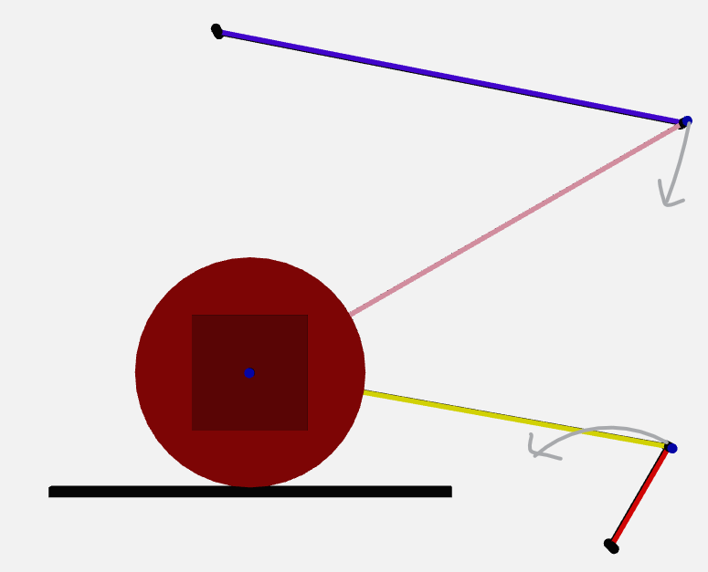

Рисунок . Начальное состояние системы

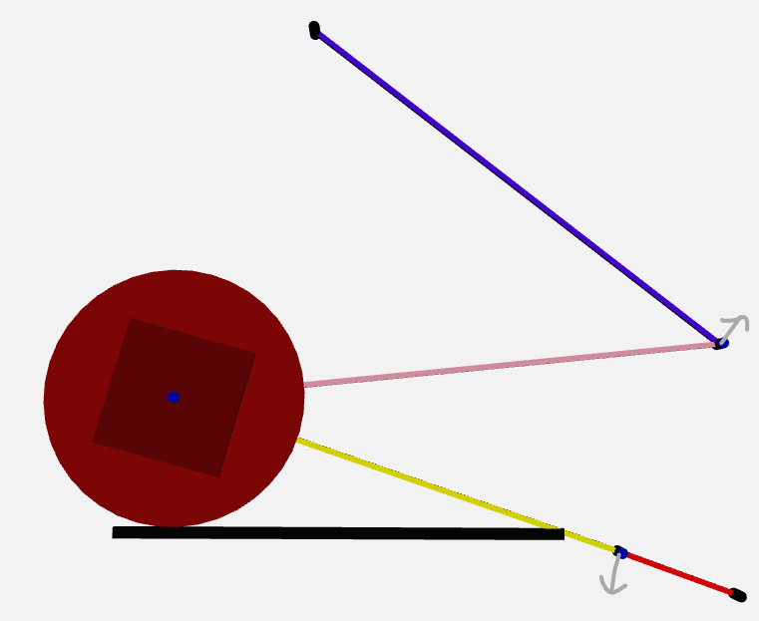

Рисунок . Первое предельное положение системы

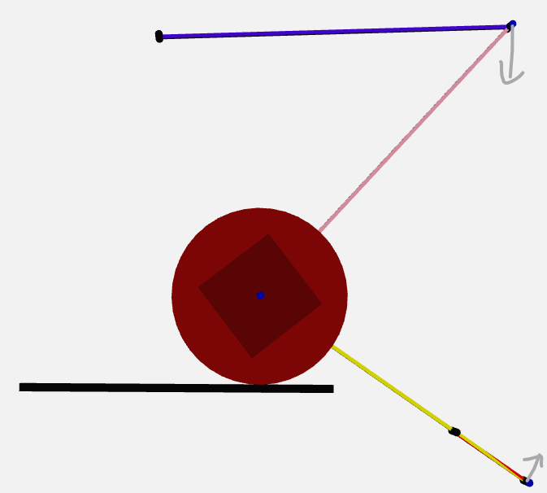

Рисунок . Второе предельное положение системы

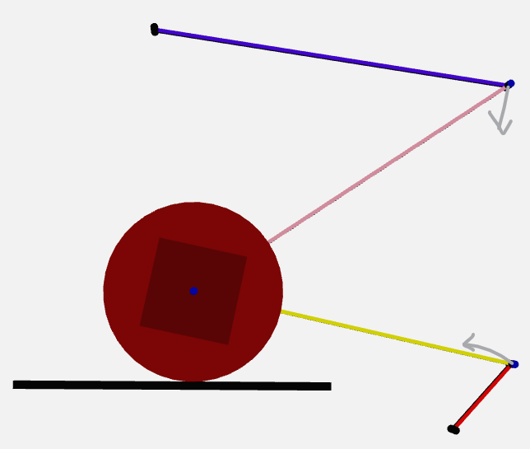

Рисунок 4. Возвращение в начальное положение

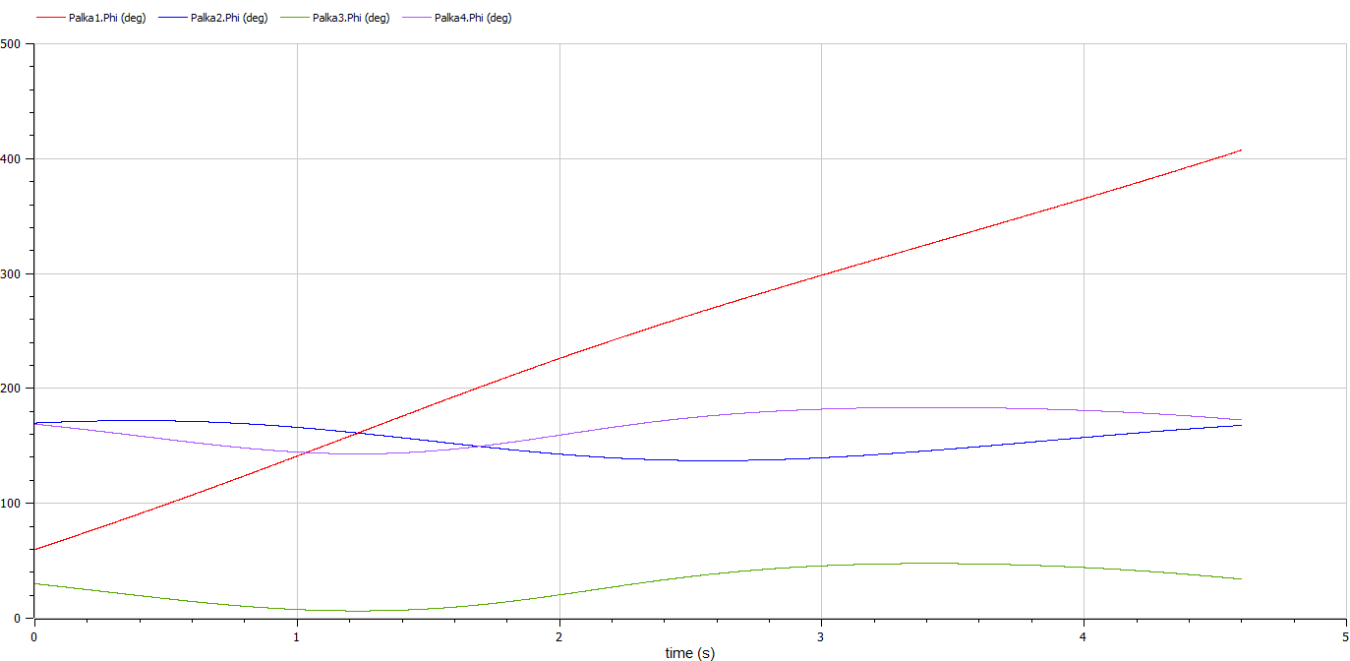

Рисунок 5. Зависимость углов от времени

**Лабораторная работа №6**

**Задание**

По заданной схеме смоделировать динамику системы плоских тел.

**Вариант 13**



Для хоть сколько то приближенного моделирования, возьмем массу связующих балок как титановые, а плоский диск сделаем из чугуна.

**Результат работы**

Код программы:

package Lab_6_Dynamica

model Body2D

parameter Modelica.Mechanics.MultiBody.Frames.Orientation orientation = Modelica.Mechanics.MultiBody.Frames.axesRotations({1, 2, 3}, {0, 0, 0}, {0, 0, 0});

parameter Real Color[3] = {0, 0, 255};

Modelica.Units.SI.Length X;

Modelica.Units.SI.Length Y;

Modelica.Units.SI.Angle Phi;

KinematicOutput Body_Out;

equation

Body_Out.X = X;

Body_Out.Y = Y;

Body_Out.Phi = Phi;

end Body2D;

connector KinematicInput

input Modelica.Units.SI.Length X;

input Modelica.Units.SI.Length Y;

input Modelica.Units.SI.Angle Phi;

end KinematicInput;

connector KinematicOutput

output Modelica.Units.SI.Length X;

output Modelica.Units.SI.Length Y;

output Modelica.Units.SI.Angle Phi;

end KinematicOutput;

model Rod2D

extends Fejzullin_Lab_5_6.laba5_kinematic.Body2D;

parameter Modelica.Units.SI.Length L = 1;

Modelica.Mechanics.MultiBody.Visualizers.Advanced.Shape RodShape(shapeType = "box", length = L, width = 0.1, height = 0.1, lengthDirection = {cos(Phi), sin(Phi), 0}, widthDirection = {0, 0, 1}, color = Color, specularCoefficient = 0.5, r = {X - L / 2 * cos(Phi), Y - L / 2 * sin(Phi), 0}, R = orientation);

equation

annotation(

experiment(StartTime = 0, StopTime = 1, Tolerance = 1e-6, Interval = 0.002));

end Rod2D;

model FreeRod

parameter Modelica.Units.SI.Length L = 2;

Rod2D Palka(L = L, Color = {0, 255, 80});

equation

Palka.X = L / 2 * sin(time);

Palka.Y = L / 2 * cos(time);

Palka.Phi = time;

annotation(

experiment(StartTime = 0, StopTime = 10, Tolerance = 1e-06, Interval = 0.0002));

end FreeRod;

model Wheel2D

extends Fejzullin_Lab_5_6.laba5_kinematic.Body2D;

parameter Modelica.Units.SI.Length R = 1;

Modelica.Mechanics.MultiBody.Visualizers.Advanced.Shape WheelShape(shapeType = "cylinder", length = 0.1, width = 2 * R, height = 2 * R, widthDirection = {cos(Phi), sin(Phi), 0}, lengthDirection = {0, 0, 1}, color = Color, specularCoefficient = 0.5, r = {X, Y, 0}, R = orientation, r_shape = {0, 0, 0});

Modelica.Mechanics.MultiBody.Visualizers.Advanced.Shape BoxShape(shapeType = "box", length = 0.2, width = R, height = R, widthDirection = {cos(Phi), sin(Phi), 0}, lengthDirection = {0, 0, 1}, color = 0.7 * Color, specularCoefficient = 0.5, r = {X, Y, 0}, R = orientation, r_shape = {0, 0, 0});

equation

annotation(

experiment(StartTime = 0, StopTime = 1, Tolerance = 1e-06, Interval = 0.002));

end Wheel2D;

model FreeWheel

parameter Modelica.Units.SI.Length R = 2;

Wheel2D Wheel(R = R, Color = {0, 255, 0});

equation

Wheel.X = R / 2 * sin(time);

Wheel.Y = R / 2 * cos(time);

Wheel.Phi = time;

annotation(

experiment(StartTime = 0, StopTime = 10, Tolerance = 1e-06, Interval = 0.0002));

end FreeWheel;

model Support2D

parameter Modelica.Units.SI.Length Xp = 0;

parameter Modelica.Units.SI.Length Yp = 0;

parameter Modelica.Units.SI.Length Xt = 0;

parameter Modelica.Units.SI.Length Yt = 0;

parameter Real Color[3] = {0, 0, 0};

parameter Modelica.Mechanics.MultiBody.Frames.Orientation orientation = Modelica.Mechanics.MultiBody.Frames.axesRotations({1, 2, 3}, {0, 0, 0}, {0, 0, 0});

Modelica.Mechanics.MultiBody.Visualizers.Advanced.Shape SupportShape(shapeType = "cylinder", length = 0.5, width = 0.2, height = 0.2, widthDirection = {1, 0, 0}, lengthDirection = {0, 0, 1}, color = Color, specularCoefficient = 0.5, r = {Xp, Yp, -0.2}, R = orientation, r_shape = {0, 0, 0});

// Additional for Dynamica Modeling

Modelica.Units.SI.Force Rx;

Modelica.Units.SI.Force Ry;

ForceOutput FO;

// End of Additional

KinematicInput Body_In;

equation

Xp = Body_In.X + Xt * cos(Body_In.Phi) - Yt * sin(Body_In.Phi);

Yp = Body_In.Y + Xt * sin(Body_In.Phi) + Yt * sin(Body_In.Phi);

// Additional for Dynamica Modeling

FO.X = Xp;

FO.Y = Yp;

FO.Fx = Rx;

FO.Fy = Ry;

FO.M = 0;

// End of Additional

annotation(

experiment(StartTime = 0, StopTime = 1, Tolerance = 1e-6, Interval = 0.002));

end Support2D;

model Joint2D

Modelica.Units.SI.Length Xsh;

Modelica.Units.SI.Length Ysh;

parameter Modelica.Units.SI.Length Xt1 = 0;

parameter Modelica.Units.SI.Length Yt1 = 0;

parameter Modelica.Units.SI.Length Xt2 = 0;

parameter Modelica.Units.SI.Length Yt2 = 0;

parameter Real Color[3] = {0, 0, 200};

parameter Modelica.Mechanics.MultiBody.Frames.Orientation orientation = Modelica.Mechanics.MultiBody.Frames.axesRotations({1, 2, 3}, {0, 0, 0}, {0, 0, 0});

Modelica.Mechanics.MultiBody.Visualizers.Advanced.Shape SupportShape(shapeType = "cylinder", length = 0.5, width = 0.2, height = 0.2, widthDirection = {1, 0, 0}, lengthDirection = {0, 0, 1}, color = Color, specularCoefficient = 0.5, r = {Xsh, Ysh, -0.2}, R = orientation, r_shape = {0, 0, 0});

KinematicInput Body_In1;

KinematicInput Body_In2;

// Additional for Dynamica Modeling

Modelica.Units.SI.Force Rx;

Modelica.Units.SI.Force Ry;

ForceOutput FO1;

ForceOutput FO2;

// End of Additional

equation

Xsh = Body_In1.X + Xt1 * cos(Body_In1.Phi) - Yt1 * sin(Body_In1.Phi);

Ysh = Body_In1.Y + Xt1 * sin(Body_In1.Phi) + Yt1 * cos(Body_In1.Phi);

Xsh = Body_In2.X + Xt2 * cos(Body_In2.Phi) - Yt2 * sin(Body_In2.Phi);

Ysh = Body_In2.Y + Xt2 * sin(Body_In2.Phi) + Yt2 * cos(Body_In2.Phi);

// Additional for Dynamica Modeling

FO1.X = Xsh;

FO1.Y = Ysh;

FO1.Fx = Rx;

FO1.Fy = Ry;

FO1.M = 0;

FO2.X = Xsh;

FO2.Y = Ysh;

FO2.Fx = -Rx;

FO2.Fy = -Ry;

FO2.M = 0;

// End of Additional

annotation(

experiment(StartTime = 0, StopTime = 1, Tolerance = 1e-6, Interval = 0.002));

end Joint2D;

model Slider2D

parameter Modelica.Units.SI.Length Xp = 0;

parameter Modelica.Units.SI.Length Yp = 0;

parameter Modelica.Units.SI.Angle Phip = 0;

parameter Modelica.Units.SI.Length Xt = 0;

parameter Modelica.Units.SI.Length Yt = 0;

Modelica.Units.SI.Length Xpol;

Modelica.Units.SI.Length Ypol;

Modelica.Units.SI.Length S;

parameter Real Color[3] = {0, 255, 255};

parameter Modelica.Mechanics.MultiBody.Frames.Orientation orientation = Modelica.Mechanics.MultiBody.Frames.axesRotations({1, 2, 3}, {0, 0, 0}, {0, 0, 0});

parameter Modelica.Units.SI.Length l = 0.3;

Modelica.Mechanics.MultiBody.Visualizers.Advanced.Shape SliderShape(shapeType = "box", length = l, width = 0.2, height = 0.2, lengthDirection = {cos(Phip), sin(Phip), 0}, widthDirection = {0, 0, 1}, color = Color, specularCoefficient = 0.5, r = {Xpol - l / 2 * cos(Phip), Ypol - l / 2 * sin(Phip), 0}, R = orientation);

KinematicInput Body_In;

equation

Xpol = Body_In.X + Xt * cos(Body_In.Phi) - Yt * sin(Body_In.Phi);

Ypol = Body_In.Y + Xt * sin(Body_In.Phi) + Yt * sin(Body_In.Phi);

Xpol = Xp + S * cos(Phip);

Ypol = Yp + S * sin(Phip);

annotation(

experiment(StartTime = 0, StopTime = 1, Tolerance = 1e-6, Interval = 0.002));

end Slider2D;

model RollCircleOnBottom

parameter Modelica.Units.SI.Length Xp = 0;

parameter Modelica.Units.SI.Length Yp = 0;

parameter Modelica.Units.SI.Angle Phip = 0;

parameter Modelica.Units.SI.Length R = 1;

Modelica.Units.SI.Length Xk;

Modelica.Units.SI.Length Yk;

Modelica.Units.SI.Length S;

parameter Real Color[3] = {0, 0, 0};

parameter Modelica.Mechanics.MultiBody.Frames.Orientation orientation = Modelica.Mechanics.MultiBody.Frames.axesRotations({1, 2, 3}, {0, 0, 0}, {0, 0, 0});

parameter Modelica.Units.SI.Length l = 3.5 * R;

Modelica.Mechanics.MultiBody.Visualizers.Advanced.Shape FlatShape(shapeType = "box", length = l, width = 0.2, height = 0.2, lengthDirection = {cos(Phip), sin(Phip), 0}, widthDirection = {0, 0, 1}, color = Color, specularCoefficient = 0.5, r = {Xp - l / 2 * cos(Phip) + 0.1 * sin(Phip), Yp - l / 2 * sin(Phip) - 0.1 * cos(Phip), 0}, R = orientation);

KinematicInput Body_In;

// Additional for Dynamica Modeling

Modelica.Units.SI.Force N;

Modelica.Units.SI.Force Ftr;

ForceOutput FO;

// End of Additional

equation

Xk = Body_In.X + R * sin(Phip);

Yk = Body_In.Y - R * cos(Phip);

Xk = Xp + S * cos(Phip);

Yk = Yp + S * sin(Phip);

der(S) = -der(Body_In.Phi) * R;

// Additional for Dynamica Modeling

FO.X = Xk;

FO.Y = Yk;

FO.Fx = (-N * sin(Phip)) - Ftr * cos(Phip);

FO.Fy = N * cos(Phip) - Ftr * sin(Phip);

FO.M = 0;

// End of Additional

annotation(

experiment(StartTime = 0, StopTime = 1, Tolerance = 1e-6, Interval = 0.002));

end RollCircleOnBottom;

model Zadanie13

parameter Modelica.Units.SI.Length L1 = 2.3;

parameter Modelica.Units.SI.Length L2 = 8.5;

parameter Modelica.Units.SI.Length L3 = 10;

parameter Modelica.Units.SI.Length L4 = 9.5;

parameter Real p = 4;

parameter Modelica.Units.SI.Angle phi0_1 = 1.046;

parameter Modelica.Units.SI.Angle phi0_2 = 2.965;

parameter Modelica.Units.SI.Angle phi0_3 = 0.523;

parameter Modelica.Units.SI.Angle phi0_4 = 2.9481;

parameter Modelica.Units.SI.Angle phip = 0;

parameter Modelica.Units.SI.Length X0 = 5;

parameter Modelica.Units.SI.Length Y0 = 0-5;

parameter Modelica.Units.SI.Length R = 2.3;

parameter Modelica.Units.SI.Length XK = X0 + L2 * cos(phi0_2) + L1 * cos(phi0_1) + R * sin(phip);

parameter Modelica.Units.SI.Length YK = Y0 + L2 * sin(phi0_2) + L1 * sin(phi0_1) - R * cos(phip);

TwoPortRod2D Palka1(L = L1, Color = {255, 0, 0}, Phi(start = phi0_1), m = L1 * p);

//Red

ThreePortRod2D Palka2(L = L2, Color = {255, 255, 0}, Phi(start = phi0_2), m = L2 * p);

// Yellow

TwoPortRod2D Palka3(L = L3, Color = {255, 170, 191}, Phi(start = phi0_3), m = L3 * p);

//Pink

TwoPortRod2D Palka4(L = L4, Color = {75, 0, 248}, Phi(start = phi0_4), m = L4 * p);

//Blue

Support2D Opora1(Xp = X0, Yp = Y0, Xt = -L1 / 2, Yt = 0);

parameter Modelica.Units.SI.Length X02 = X0 + L1 * cos(phi0_1) + L2 * cos(phi0_2) + L3 * cos(phi0_3) + L4 * cos(phi0_4);

parameter Modelica.Units.SI.Length Y02 = Y0 + L1 * sin(phi0_1) + L2 * sin(phi0_2) + L3 * sin(phi0_3) + L4 * sin(phi0_4);

Support2D Opora2(Xp = X02, Yp = Y02, Xt = L4 / 2, Yt = 0);

Joint2D Sharnir1(Xt1 = L1 / 2, Yt1 = 0, Xt2 = -L2 / 2, Yt2 = 0);

Joint2D Sharnir2(Xt1 = L2 / 2, Yt1 = 0, Xt2 = -L3 / 2, Yt2 = 0);

Joint2D Sharnir3(Xt1 = L3 / 2, Yt1 = 0, Xt2 = -L4 / 2, Yt2 = 0);

Joint2D Sharnir4(Xt1 = L2 / 2, Yt1 = 0, Xt2 = 0, Yt2 = 0);

TwoPortWheel2D Koleso(R = R, Color = {150, 0, 0}, m = Modelica.Constants.pi * R * R * p * 2);

RollCircleOnBottom Kachenie(R = R, Xp = XK, Yp = YK, Phip = phip);

equation

connect(Palka1.Body_Out, Opora1.Body_In);

connect(Palka1.Body_Out, Sharnir1.Body_In1);

connect(Palka2.Body_Out, Sharnir1.Body_In2);

connect(Palka2.Body_Out, Sharnir2.Body_In1);

connect(Palka3.Body_Out, Sharnir2.Body_In2);

connect(Palka3.Body_Out, Sharnir3.Body_In1);

connect(Palka4.Body_Out, Sharnir3.Body_In2);

connect(Palka4.Body_Out, Opora2.Body_In);

connect(Palka2.Body_Out, Sharnir4.Body_In1);

connect(Koleso.Body_Out, Sharnir4.Body_In2);

connect(Koleso.Body_Out, Kachenie.Body_In);

connect(Palka1.F_A, Opora1.FO);

connect(Palka1.F_B, Sharnir1.FO1);

connect(Palka2.F_A, Sharnir1.FO2);

connect(Palka2.F_B, Sharnir2.FO1);

connect(Palka3.F_A, Sharnir2.FO2);

connect(Palka3.F_B, Sharnir3.FO1);

connect(Palka4.F_A, Sharnir3.FO2);

connect(Palka4.F_B, Opora2.FO);

connect(Palka2.F_C, Sharnir4.FO1);

connect(Koleso.F_A, Sharnir4.FO2);

connect(Koleso.F_B, Kachenie.FO);

annotation(

experiment(StartTime = 0, StopTime = 12, Tolerance = 1e-06, Interval = 0.000380964));

end Zadanie13;

// New Obljects for Dynamica Modeling

connector ForceInput

input Modelica.Units.SI.Length X;

input Modelica.Units.SI.Length Y;

input Modelica.Units.SI.Force Fx;

input Modelica.Units.SI.Force Fy;

input Modelica.Units.SI.MomentOfForce M;

end ForceInput;

connector ForceOutput

output Modelica.Units.SI.Length X;

output Modelica.Units.SI.Length Y;

output Modelica.Units.SI.Force Fx;

output Modelica.Units.SI.Force Fy;

output Modelica.Units.SI.MomentOfForce M;

end ForceOutput;

model TwoPortBody2D

parameter Modelica.Mechanics.MultiBody.Frames.Orientation orientation = Modelica.Mechanics.MultiBody.Frames.axesRotations({1, 2, 3}, {0, 0, 0}, {0, 0, 0});

parameter Real Color[3] = {0, 0, 255};

parameter Modelica.Units.SI.Acceleration g = 9.81;

parameter Modelica.Units.SI.Mass m = 1;

Modelica.Units.SI.Length X;

Modelica.Units.SI.Length Y;

Modelica.Units.SI.Angle Phi;

Modelica.Units.SI.Velocity Vx;

Modelica.Units.SI.Velocity Vy;

Modelica.Units.SI.AngularVelocity Omega;

Modelica.Units.SI.Length CA[2];

Modelica.Units.SI.Length CB[2];

KinematicOutput Body_Out;

ForceInput F_A;

ForceInput F_B;

equation

Body_Out.X = X;

Body_Out.Y = Y;

Body_Out.Phi = Phi;

der(X) = Vx;

der(Y) = Vy;

der(Phi) = Omega;

CA = {F_A.X - X, F_A.Y - Y};

CB = {F_B.X - X, F_B.Y - Y};

m * der(Vx) = F_A.Fx + F_B.Fx;

m * der(Vy) = F_A.Fy + F_B.Fy - m * g;

m * der(Omega) = CA[1] * F_A.Fy - CA[2] * F_A.Fx + F_A.M + CB[1] * F_B.Fy - CB[2] * F_B.Fx + F_B.M;

end TwoPortBody2D;

model TwoPortRod2D

extends Fejzullin_Lab_5_6.Lab_6_Dynamica.TwoPortBody2D;

parameter Modelica.Units.SI.Length L = 1;

Modelica.Mechanics.MultiBody.Visualizers.Advanced.Shape RodShape(shapeType = "box", length = L, width = 0.1, height = 0.1, lengthDirection = {cos(Phi), sin(Phi), 0}, widthDirection = {0, 0, 1}, color = Color, specularCoefficient = 0.5, r = {X - L / 2 * cos(Phi), Y - L / 2 * sin(Phi), 0}, R = orientation);

parameter Modelica.Units.SI.MomentOfInertia J = m * L ^ 2 / 12;

equation

end TwoPortRod2D;

model TwoPortWheel2D

extends Fejzullin_Lab_5_6.Lab_6_Dynamica.TwoPortBody2D;

parameter Modelica.Units.SI.Length R = 1;

Modelica.Mechanics.MultiBody.Visualizers.Advanced.Shape WheelShape(shapeType = "cylinder", length = 0.1, width = 2 * R, height = 2 * R, widthDirection = {cos(Phi), sin(Phi), 0}, lengthDirection = {0, 0, 1}, color = Color, specularCoefficient = 0.5, r = {X, Y, 0}, R = orientation, r_shape = {0, 0, 0});

Modelica.Mechanics.MultiBody.Visualizers.Advanced.Shape BoxShape(shapeType = "box", length = 0.2, width = R, height = R, widthDirection = {cos(Phi), sin(Phi), 0}, lengthDirection = {0, 0, 1}, color = 0.7 * Color, specularCoefficient = 0.5, r = {X, Y, 0}, R = orientation, r_shape = {0, 0, 0});

parameter Modelica.Units.SI.MomentOfInertia J = m * R ^ 2 / 2;

equation

end TwoPortWheel2D;

model ThreePortBody2D

parameter Modelica.Mechanics.MultiBody.Frames.Orientation orientation = Modelica.Mechanics.MultiBody.Frames.axesRotations({1, 2, 3}, {0, 0, 0}, {0, 0, 0});

parameter Real Color[3] = {0, 0, 255};

parameter Modelica.Units.SI.Acceleration g = 9.81;

parameter Modelica.Units.SI.Mass m = 1;

Modelica.Units.SI.Length X;

Modelica.Units.SI.Length Y;

Modelica.Units.SI.Angle Phi;

Modelica.Units.SI.Velocity Vx;

Modelica.Units.SI.Velocity Vy;

Modelica.Units.SI.AngularVelocity Omega;

Modelica.Units.SI.Length CA[2];

Modelica.Units.SI.Length CB[2];

Modelica.Units.SI.Length CC[2];

KinematicOutput Body_Out;

ForceInput F_A;

ForceInput F_B;

ForceInput F_C;

equation

Body_Out.X = X;

Body_Out.Y = Y;

Body_Out.Phi = Phi;

der(X) = Vx;

der(Y) = Vy;

der(Phi) = Omega;

CA = {F_A.X - X, F_A.Y - Y};

CB = {F_B.X - X, F_B.Y - Y};

CC = {F_C.X - X, F_C.Y - Y};

m * der(Vx) = F_A.Fx + F_B.Fx + F_C.Fx;

m * der(Vy) = F_A.Fy + F_B.Fy + F_C.Fy - m * g;

m * der(Omega) = CA[1] * F_A.Fy - CA[2] * F_A.Fx + F_A.M + CB[1] * F_B.Fy - CB[2] * F_B.Fx + F_B.M + CC[1] * F_C.Fy - CC[2] * F_C.Fx + F_C.M;

end ThreePortBody2D;

model ThreePortWheel2D

extends Fejzullin_Lab_5_6.Lab6_Dynamic.ThreePortBody2D;

parameter Modelica.Units.SI.Length L = 1;

Modelica.Mechanics.MultiBody.Visualizers.Advanced.Shape RodShape(shapeType = "box", length = L, width = 0.1, height = 0.1, lengthDirection = {cos(Phi), sin(Phi), 0}, widthDirection = {0, 0, 1}, color = Color, specularCoefficient = 0.5, r = {X - L / 2 * cos(Phi), Y - L / 2 * sin(Phi), 0}, R = orientation);

parameter Modelica.Units.SI.MomentOfInertia J = m * L ^ 2 / 12;

equation

end ThreePortWheel2D;

model ThreePortRod2D

extends Fejzullin_Lab_5_6.Lab_6_Dynamica.ThreePortBody2D;

parameter Modelica.Units.SI.Length L = 1;

Modelica.Mechanics.MultiBody.Visualizers.Advanced.Shape RodShape(shapeType = "box", length = L, width = 0.1, height = 0.1, lengthDirection = {cos(Phi), sin(Phi), 0}, widthDirection = {0, 0, 1}, color = Color, specularCoefficient = 0.5, r = {X - L / 2 * cos(Phi), Y - L / 2 * sin(Phi), 0}, R = orientation);

parameter Modelica.Units.SI.MomentOfInertia J = m * L ^ 2 / 12;

equation

end ThreePortRod2D;

// End of New Objects

end Lab_6_Dynamica;

Графики:



Рисунок 6. Начальное состояние системы



Рисунок 7. Первое предельное положение системы



Рисунок 8. Второе предельное положение системы



Рисунок 9. Возвращение в начальное положение

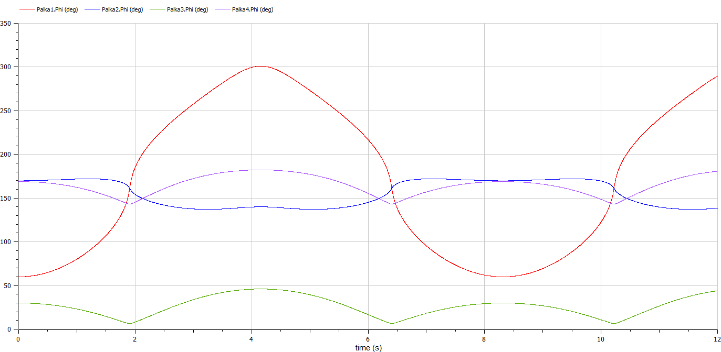

Рисунок 10. Зависимость углов от времени